Honeywell Genesis 7580g
COM-Modus
05.06.2024
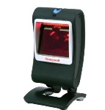
Resetting the Factory Defaults: Activate Defaults
Presentation Aimer Mode: Interlaced
Cellular Telephone Reading Mode: On
Prefix: STX
Suffix: ETX


DEFALT;PDCAIM2;TRMUSB130;HSTACH18;HSTDCH20;DECCEL1;PREBK29902;SUFBK29903.

